K5 Planner
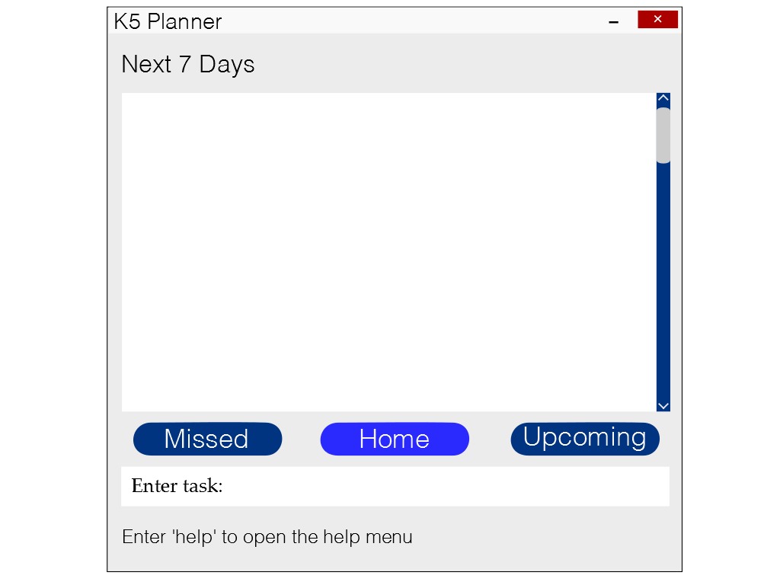
1. 9th Feb Assignment Submission
2. 11th Feb Meeting at SR2
3. 13th Feb Lunch Appointment 1pm to 2 pm
4. No Date Do Tutorial 1
5. No Date Internship Application

Supervisor: Huang Da Extra feature: Recurring Tasks
Sakib Bin Farooque Rahmatullah  Team lead, Deliverables and Deadlines | Le Minh Thu  Documentation, Integration | Karthikeyan s/o Shanmugam  Testing | Lee Thye Jie  Scheduling and Tracking,

User guide

Congratulations on downloading K5 User Guide! Plan each day with our easy-to-use desktop planner. This User Guide provides you with detailed descriptions on the various functionalities of K5 allowing you to use K5 effectively.

System Requirements
K5 is compatible with Windows XP, Windows Vista, Windows 7 and Windows 8.1 Operating System with Microsoft .NET framework 4.0 installed.
Is this the non functional requirements?
Anatomy of K5
Type of views

There are 3 main type of views in the K5 Planner: Home, Upcoming and Missed. The current view will be represented by the highlighted button. Users may switch between windows according to their preference.

Home View

The Home view shows the user all the entries that have a due date within the next 7 days and the entries that have no due date.

Upcoming View

The Upcoming view shows the user all the entries that he has entered.

Missed View
The missed view shows the user all the entries with a due date that he has not marked completed. When an entry moves to the missed view, the button will turn red to notify the user that he has missed a deadline.

Command formats:
There are 7 basic commands: add, delete, undo, search, clear, edit and help

1. Add an entry
Format: add <entry name>;<keywords><information>
Functionality:
‘add’ function allows information fields to be input in any order after the <entry name> command.
Information fields are input with the standard format <keywords> <information>.
Separate information fields are separated with the “;” symbol.
Keywords | Function
at <location> | To specify location
time from <start time> to <end time> | To specify time period i.e. time from 3pm to 3am
date from<start date> to <end date> | To specify start and end dates (DD/MM/YY)
by <due date> | To specify due date
remark <remarks> | To include any remarks about entry
#impt | marks the event as important

Examples:
add meeting #impt; at office; from 9am to 10am
add concert; at esplanade
add assignment; remark attach tables

2. Edit an entry

Format: edit <task number>; <keyword> <content from selected task>
Functionality: edit allows the user to edit specific details of an entry.
Each task shown on the screen has a serial number associated with it appearing on the left of the task description. If the task to be edited does not appear on the screen, search for the task (refer to section for user guide on search), identify the task number from the search list.
Enter the commands in the following format:
edit<task number>: <keyword> <content from selected task>
The task number is the corresponding task number of the entry. The keywords will follow the same format as the add function. The new content for the keyword will replace the current content.

Keywords | Function
at <location> | To specify location
time from <start time> to <end time> | To specify time period i.e. time from 3pm to 3am
date from<start date> to <end date> | To specify start and end dates (DD/MM/YY)
by <due date> | To specify due date
remark <remarks> | To include any remarks about entry
#impt | marks the event as important
1. 9th Feb Assignment Submission
2. 11th Feb Meeting at SR2
3. 13th Feb Lunch Appointment 1pm to 2 pm
4. No Date Do Tutorial 1
5. No DateInternship Application

User can edit necessary information of the task and press enter to confirm the changes. Once the task is edited, the “successfully edited” message will be shown at the bottom of the screen.
Example: edit 2 by 14/02/2015
This will change the due date of entry 2 to 14th Feb instead of 11th Feb
3. Delete an entry:

Format: delete <task number>

Functionality: Each task shown on the screen has a number associated with it appearing on the left hand side of the task description. If the task to be deleted does not appear on the screen, search for the task (refer to section for user guide on search), identify the task number from the search list and follow the above format.

If the task is successfully deleted, the “successfully deleted” message will be shown at the bottom of the screen.

4. Clear entries:

Format: clear

This command clears all the tasks in your list. Upon pressing enter, a dialog box will appear asking you to confirm your operation. Choose <Y> for Yes or <N> for No.

5. Undo:

Format: undo

This command undoes accidental deletes and edits.
This command can only be executed after a successful <delete> or <edit> command.
After a successful delete or edit command, the text “Enter ‘undo’ to undo the last change” will appear below the textbox in the event the user has accidentally done something and needs to know the undo command.

6. Search:

Format: search <desired keyword>

This command will search for the <desired keyword> in all entries in the planner. All entries that contain the <desired keyword> will be displayed.

7. Help:

Format: help

This command opens a help menu that lists down the various commands and their functions. The text “Enter ‘help’ to open the help menu” will appear below the textbox in the event the user does not know what to do.

Appendix A: User stories. As a user, …

No. | Functionality (As a user I can…) | Purpose
1 | add entries in a single command | so that I work faster
2 | delete entries in a single command | so that I work faster
3 | undo changes quickly | so that my mistakes are not permanent
4 | use the search feature | to search for any tasks from the list
5 | can change specific details in entries | so that I don’t need to delete the old entry and enter a completely new one
6 | view my tasks categorized by importance | so that I know which one needs more attention
7 | view my tasks in chronological order | so I know which to do first
8 | mark my tasks as completed | so I know which are done
9 | add start and end tasks for a task | so that I know when to start and end the task
10 | can receive notifications for upcoming deadlines | so that I know a task needs to be completed soon
11 | I can record: Tasks/ Events, Time, Venue, Remarks | so I can view and edit them individually
12 | I know that there is a save feature | so that when I close and reopen the app, my information is saved
13 | I can navigate through the tasks easily | so I can view the list easily
14 | I can view past tasks and events | if I ever need to recall anything
15 | I can scroll down the list of items | to view the list easily
16 | I can click on help if I am unsure | so that I can refer to the commands and shortcuts
17 | I can enter recurring tasks easily | so that I don’t have to enter them one by one
18 | I can save the storage file anywhere | so that I can access it on different computers
19 | I can use the application even without Internet | so that I can use it anywhere

Medium Priority

No. | Functionality (As a user I can…) | Purpose
1 | receive notification for missed deadlines | so that I know that a deadline has been missed
2 | hide outdated tasks | so that if I don’t want to view them, they won’t be on the screen
3 | use hotkeys to access the application | so that it is easily accessible
4 | choose to have the application open in one corner of the screen | so I can easily view upcoming tasks

Low priority

No. | Functionality (As a user I can…) | Purpose
1 | enter tasks using short form | so that it is faster
2 | be notified if the task being entered has a duplicate | so that I can avoid duplication
3 | can add checklists to multi-stage tasks | so that I can keep track of smaller tasks that fall under a major task
4 | I can block multiple time slots if unsure about a task and the application will automatically delete the other time slots when one is confirmed | so that I can place task in planner even without a confirmed timing and prevent clashes
5 | I can sync my tasks to other devices | so that I can use the planner from other devices
6 | I can have suggested words that I commonly use | so that I can type faster
7 | I can sync my planner with Google Calendar | so that I can use both the application and google calendar

Appendix B: Non-Functional Requirements

Appendix C: Product survey

Product: Any.do Documented by: Karthikeyan s/o Shanmugam

Strengths:

- Easy to add new tasks – just click add and type in task and hit enter
- Easy to mark as done – just mouse over task, click on the tick icon that appears
- Easy to update and delete
- Tasks marked as done continue to appear at the bottom with a strikethrough allowing user to keep track of work that is done.
- Can sync with phone and computer as long as there is internet.
- Good categorisation - can sort according to “today, tomorrow, upcoming, someday” or into groups “personal, work, <add own name> etc”
- Can add a text note (picture, video, camera, attachment, voice recording)
- Can add subtasks
- Can add Reminders for tasks
- Can collaborate tasks with other people using same application
- Can mark tasks as important or special attention
- Can order tasks according to importance/priority
- GUI is simple, sleek and easy to use
- Has good flexibility since it is not really a command input type organiser. Just input exactly what the task is, and it appears as so.
- Can search for tasks by typing in keywords
- Supports recurring tasks

Weaknesses:

- Web-based application – so there is a need to go to the site to use it. Not a desktop application
- Since its web based, it cannot be accessed on computer without internet. Possible to access in on phone app without internet access.
- Cannot undo changes
- No support for timed task. Since its purely text based, not like a calendar where it is possible to block out time, it will not be able to tell if there is a clash in timing of task

Product: S Planner Documented by: Le Minh Thu

Strengths:
- Ability to sort tasks in chronological order of due dates
- Ability to sync entries to Google Calendar, which can be accessed using computer
- Ability to differentiate tasks of different priorities
- Ability to notify conflicting events
- Ability to use the program without internet
Weaknesses:
- Cannot categorize tasks according to user’s preferences
- Cannot clear the entire list of tasks

Product: Outlook Calendar Documented by: Lee Thye Jie

Strengths:
- Allows syncing across devices
- Colour-coded entries for different categories
- Ability to import/export new calendars
- Clear indication of the current day
- Extensive information fields for individual entries e.g. Location, Reminder etc.
- Simple, clear interface

Weaknesses:
- No search function
- Unable to add tags to entries
- If there are too many entries on a day, the newer entries are not visible until the view mode is changed
Product: Google Calendar Documented by: Sakib Bin Farooque Rahmatullah

Strengths:
- Ability to take in info by single command
- Ability to colour code items
- Ability to rank items by priority
- Ability to set reminders
- Ability to add locations
- Ability to add remarks
- Ability to set durations
- Ability to recurring events
Weaknesses:
- Settings page is very large and troublesome to change items one by one
- Need internet to sync

